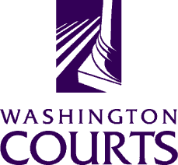

January 24, 2020

TO: Judges, Commissioners, County Clerks, Court Administrators, Libraries, Attorneys, and Public

FROM: Ashley Tam, AOC Sr. Legal Analyst

RE: Summary of Changes to 10.77 RCW Forms (January 2020)

The Washington Pattern Forms Committee updated two forms in the 10.77 RCW forms set, located at: http://www.courts.wa.gov/forms/?fa=forms.static&staticID=14#MentalProceedings.

Specifically, MP 240 – Order for Felony Competency Restoration Treatment and MP 260 – Order Dismissing Felony Charges and Directing Civil Commitment Evaluation were modified to account for changes in the law over time, improve form accuracy, and increase the clarity of information contained on these forms. Due to the significant changes made to these forms, we did not create a detailed summary of changes. Instead, we request that you use the new forms.

Please provide any feedback about Washington Court Pattern Forms at:
http://www.courts.wa.gov/forms/?fa=forms.formsComments.

Thank you.

